**CAMPUS CLEANING ACTIVITY (SWATCH PAKWADA) ON 09-03-2022**

NSS Unit of our College Cleaned our campus premises nearby the Waste Water Management Plant and nearby the landscape areas of our college on 09-03-2022 as a part of SWATCH PAKWADA Scheme announced by our central Government.

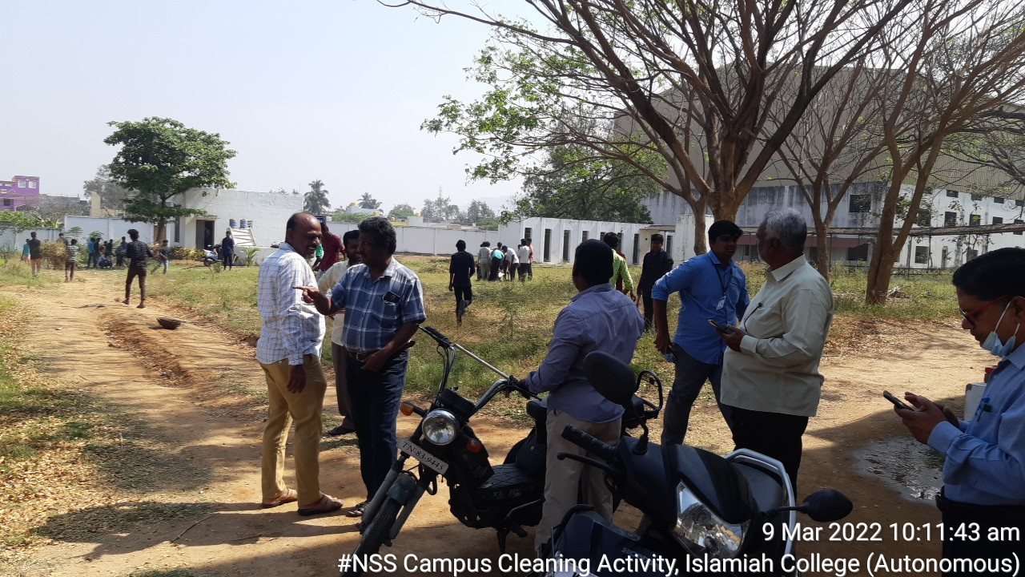

(Our Volunteers, Programme Officers in the landscapes of Waste Water Management Plant, Dr. T. Mohammed Ilyas, principal of our College supervising the cleaning activities)