**CAMPUS CLEANING ACTIVITY (SWATCH PAKWADA) ON 08-03-2022**

NSS Unit of our College Cleaned our campus premises nearby the Department of Physics and premises opposite to the main buildings of our college on 08-03-2022 as a part of SWATCH PAKWADA Scheme announced by our central Government.

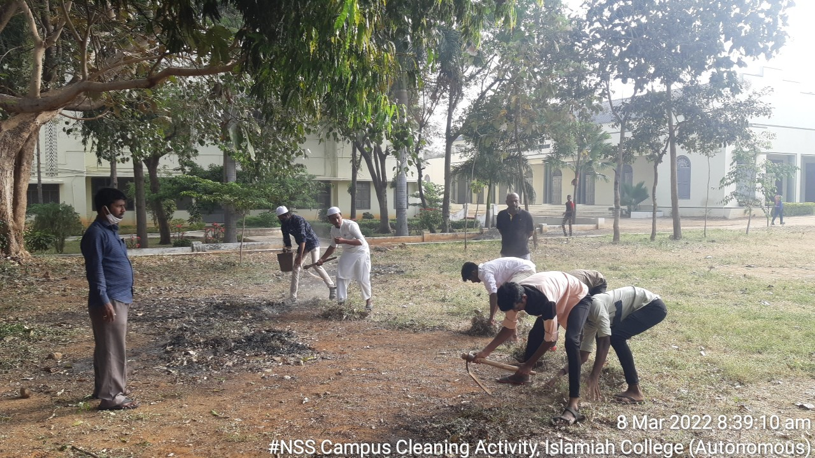

(Our Volunteers cleaning the premises opposite to the main building of our college with Programme Officers)

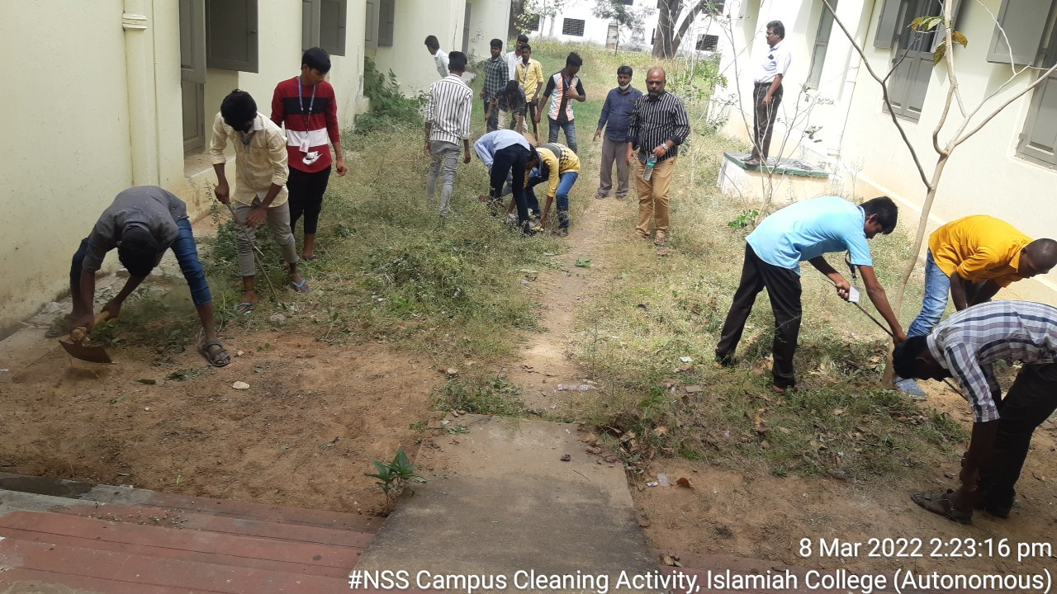

(Our Volunteers cleaning the surrounding areas of the Physics Department Building)