**CAMPUS & VERMICOMPOST CLEANING ACTIVITY (SWATCH PAKWADA) ON 07-03-2022**

NSS Unit of our College initiated the Clean Campus & Green Campus Activity in our premises as a part of SWATCH PAKWADA Scheme announced by our central Government. Volunteers are started cleaning the college play ground and Vermi compost tank of our Enviro Club from 07-03-2022.

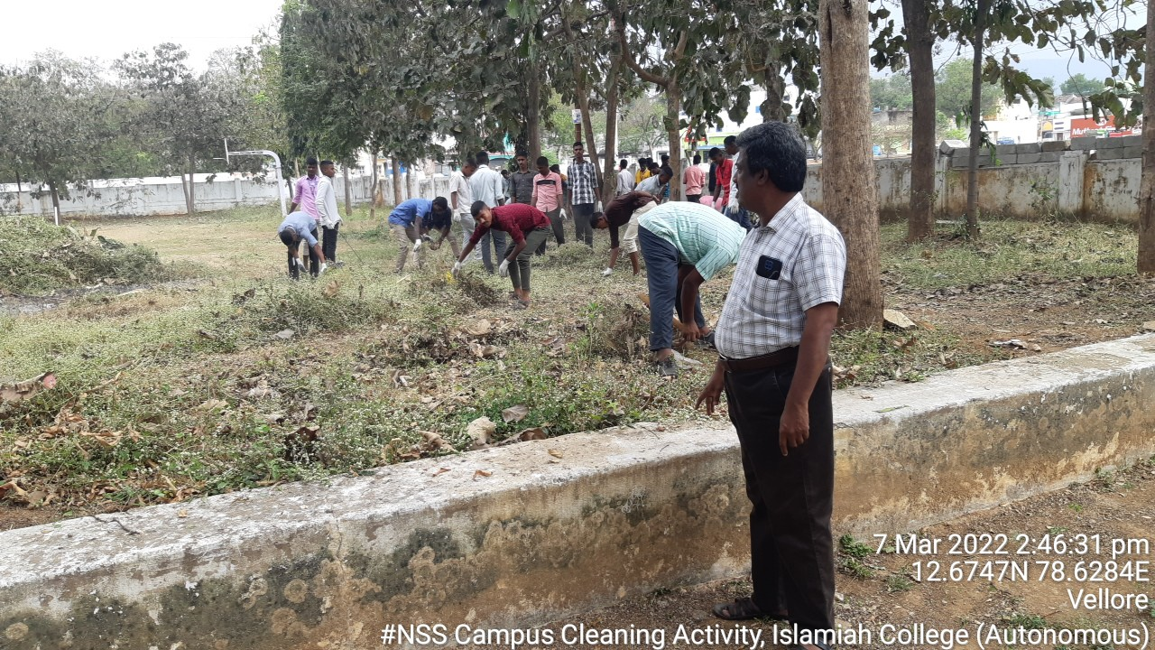

(Our Volunteers Cleaning the Volley Ball & Basket Ball Court along with Programme Officers)

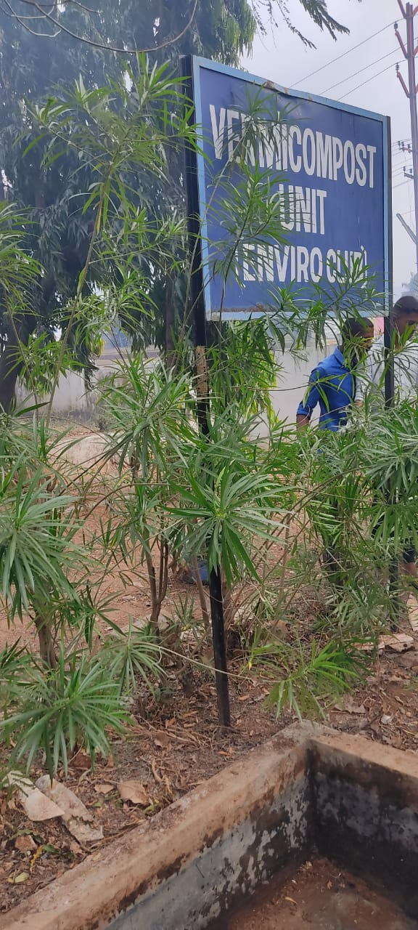

(Our Volunteers cleaning the Vermicompost tank of Enviro-Club)