**DEPARTMENT OF COMPUTER SCEINCE**

**ISLAMIAH COLLEGE (AUTONOMOUS),**

**NEWTOWN, VANIYAMBADI-635752**

**Prof. A. A. Khadar Maideen, M.C.A., M.Phil.,**

**Head and Associate Professor of Computer Science**

Date : 09-09-2024

**Report on an Invited Talk by Mr. Mazharullah Attar**

The invited talk on "Accelerate Job Leading" was held on 9th September 2024 at the Seminar Hall, Islamiah College (Autonomous), Vaniyambadi. The session was conducted by Mr. Mazharullah Attar, a distinguished software expert and alumni of our institution, currently working in the USA. The talk aimed at guiding students on how to effectively navigate the job market, identify and acquire essential skills, and prepare a professional resume.

The event began with a welcome address delivered by the Principal, Dr. T. Afser Basha. In his address, he warmly welcomed Mr.Mazharullah and expressed gratitude for his willingness to share his valuable experience and insights with the students. He emphasized the importance of such sessions in preparing students for the competitive job market.

### Key Highlights of the Talk:

Market Demand Analysis: Mr. Mazharullah provided a detailed analysis of the current job market, with a specific focus on the tech industry. He discussed emerging trends, including the rise of AI, cloud computing, cybersecurity, and data science, emphasizing the growing demand for professionals skilled in these areas. He encouraged students to stay updated with industry trends and align their career goals accordingly.

Skills Required for Success: He outlined a comprehensive list of both technical and soft skills that are highly sought after by employers. Some of the critical technical skills he highlighted included:

* Proficiency in programming languages (e.g., Python, Java, and JavaScript)
* Knowledge of cloud platforms (AWS, Azure)

Experience in software development and data analytics On the soft skills front, he stressed the importance of Professional Resume Preparation. Mr. Attar offered valuable tips on creating a compelling resume that stands out to recruiters. He stressed the importance of tailoring resumes to the specific job being applied for, highlighting relevant skills and experiences. He also provided insights on how to present projects, internships, and extracurricular activities effectively on a resume. Furthermore, he encouraged students to focus on building a strong LinkedIn profile to enhance their online presence.

The talk was highly engaging, with Mr. Mazharullah encouraging students to ask questions and interact with him throughout the session. He concluded the session by motivating students to stay determined and continuously work on improving their skill set to meet the ever-evolving demands of the job market.

The session ended with a vote of thanks by Mr. B. Junaid Ahmed, Asst. Professor, Dept of Computer Science, expressing their appreciation for Mr. Mazharullah Attar’s time and valuable insights. Overall, the event was a great success, providing students with practical knowledge and inspiration to accelerate their job search and career growth. The programme received overwhelming response with more than 200 students including faculty members.

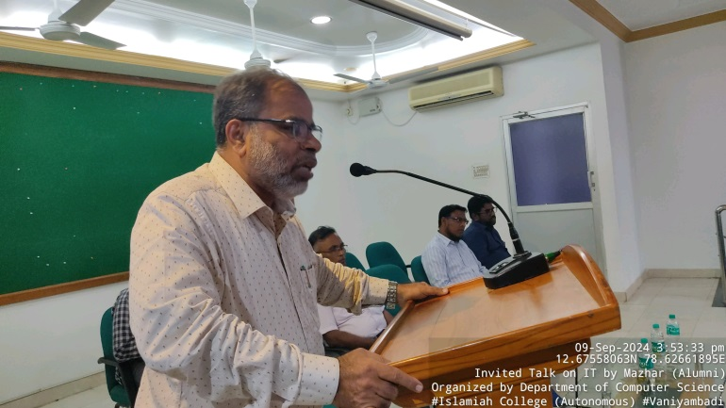**Invited Talk by Mr. Mazharullah Attar held on 09-09-2024**

