**PG & RESEARCH DEPARTMENT OF HISTORY**

**ISLAMIAH COLLEGE (AUTONOMOUS)**

**VANIYAMBADI**

02.09.2024

Our college has signed a Memorandum of Understanding with the Falcon Civil Services Academy established by the Falcon Group of Institutions, Bengaluru. Accordingly, our college will be one of the 80 centres providing free Online Civil Services Coaching / Training classes for prospective aspirants of our college provided by the Falcon Civil Service Academy. The classes conducted by the faculty of Falcon Civil Services Academy at Bangalore on every Saturday from 1: 30 pm to 5:30 pm would be viewed by interested civil service aspirants from Islamiah College through the Online Zoom platform. The aim of the programme is to provide free online civil services coaching/training classes across India for the marginalized students. The Department of History would coordinate the programme on behalf of our College with Mr. D. Abul Fazal as Programme coordinator of the Programme. The Programme was launched at Bengaluru on 31th August 2024 (Saturday) by Honourable Speaker of Karnataka Assembly Mr. U T Khader, Honourable Speaker of Karnataka Assembly, Mr. Rizwan Arshad, MLA Shivajinagar, Bengaluru and Mr. Abdul Subhan, Falcon Group of Institutions, Bengaluru. Few IAS and IPS officers participated and felicitated the function and motivated the students. Even before the inaugural in the first session at 1.30 p. m. afternoon there was an orientation from the faculty of Falcon about the different stages of Civil Services Exam, the Syllabus, question paper patterns and the ways of preparation.

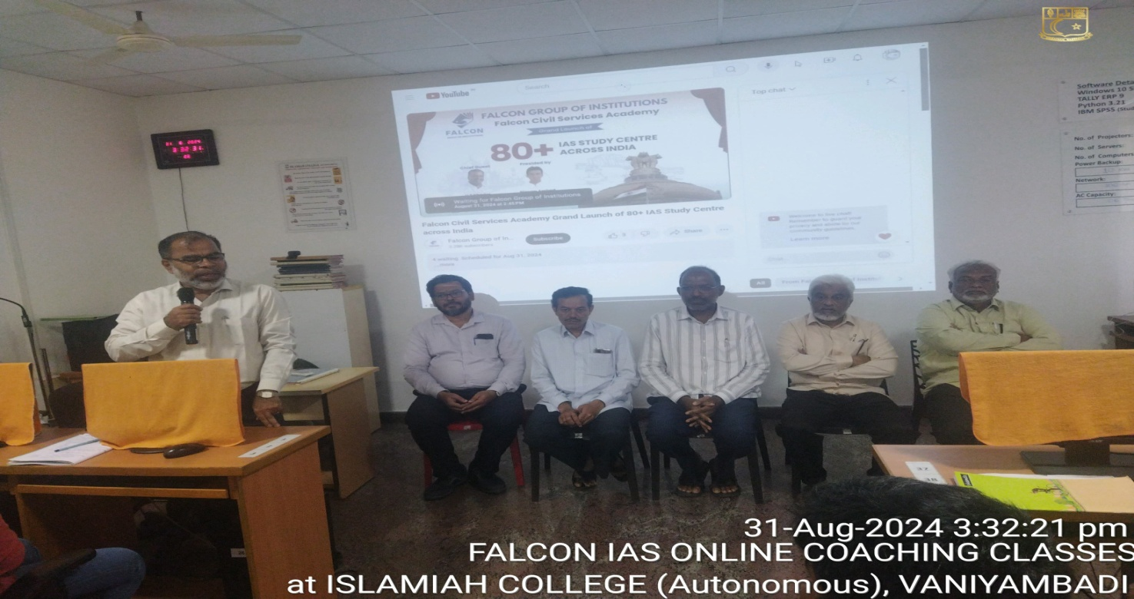

The inaugural programme for the launch of this 100 hrs. coaching programme was held simultaneously on 31 August 2024 in the Commerce Lab in our college.This inauguration programme was attended by Janab L. M. Muneer Ahamed, the Secretary and Correspondent, Dr. T. Mohamed Ilyas, Former Principal of our College, Dr. T. Afsar Basha, Principal of our college, Dr. S. Tahir Hussainy, Vice Principal (Administration) and Dr. Shaikh Khader Nawaz, Vice Principal (Academic). The Head and all faculty members of the department had made adequate arrangements for the programme. 69 students of our college attended this programme in the Commerce Lab.

