**PG& REARCH DEPARTMENT OF HISTORY**

**ISLAMIAH COLLEGE (AUTONOMOUS)**

**VANIYAMBADI**

12.08.2024

The Department students took the Anti- Drug Awareness Pledge on 12th August 2024.The I B.A., II B.A., I M.A. & II M.A. History students had taken the pledge in a function organized by the Tamil Nadu Police near Vaniyambadi Bus Stand under the presidentship of Honourable Superintendent of Police, Tirupattur District. The Honourable Vaniyambadi Municipal Chairman and the Deputy Superintendent of Police, Vaniyambadi were present in the function.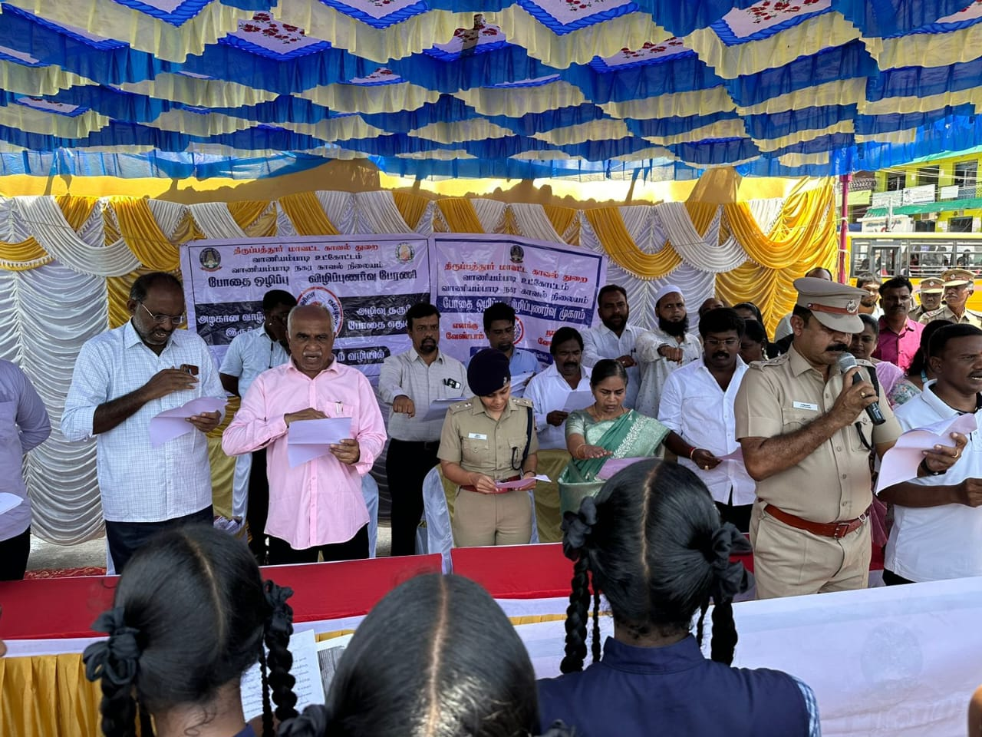The III B.A. History students had taken the pledge in the classroom (Hall no.310) at 11 a.m.

