Report on Four-Day Science Fest 2025
Thiruvalluvar University, Vellore organized a four-day Science Fest-2025 from 21-01-2025 to 24-01-2025 to provide a platform for College students to showcase their talents in Science and Technology. Total of 13 students from our college II B.Sc. Computer science -31123U18032, 31123U18034, 31123U18039, 31123U18043, 31123U18050, 31123U18051, II B.Sc. Chemistry 31123U17012,31123U17016, I B.Sc.Chemistry-31124U17025 ,31124U17026, 31124U17028 , II BBA - 31123U08011, I B.Sc. Biotechnology - 31124U16027, along with four faculty members Dr. N. Nadeem Afroze, Dr.S.U.Mohammed Riyaz, Dr.P Muzammil , Dr.S.Balakrishnan participated and won first prizes in Science talk competition and Sciecne Exhibition competition.
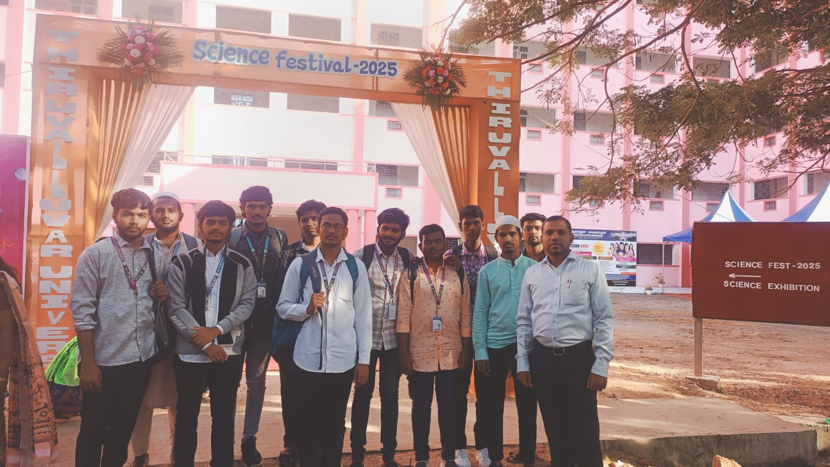
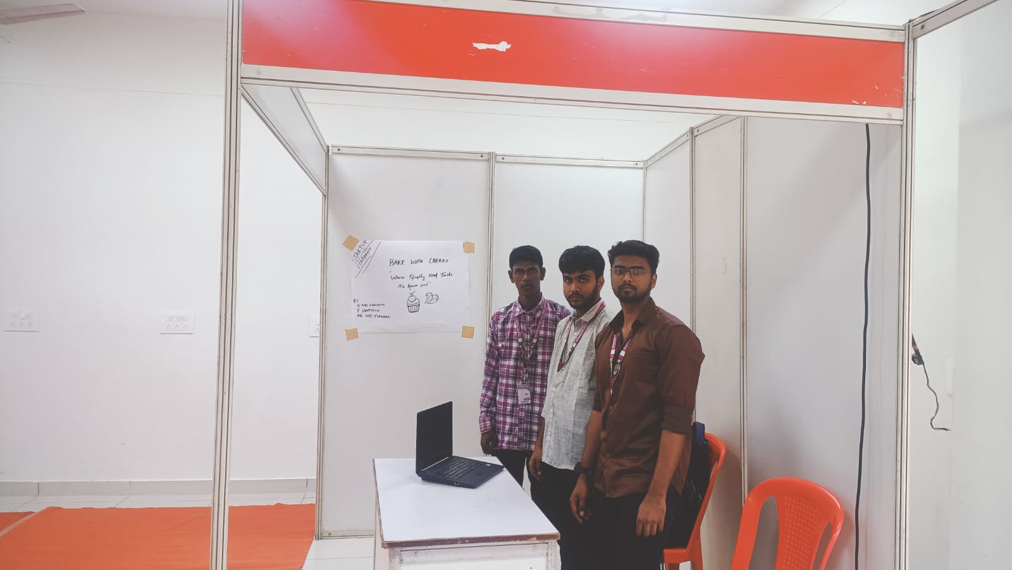
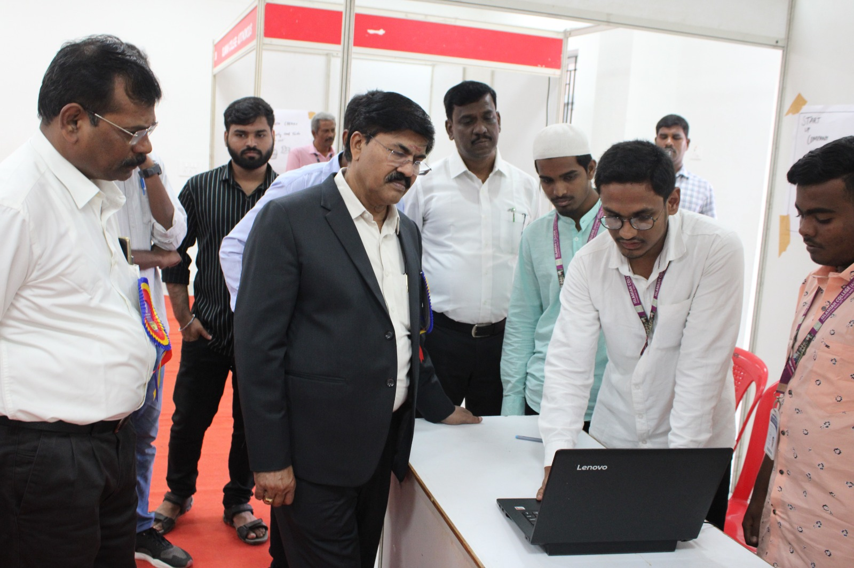
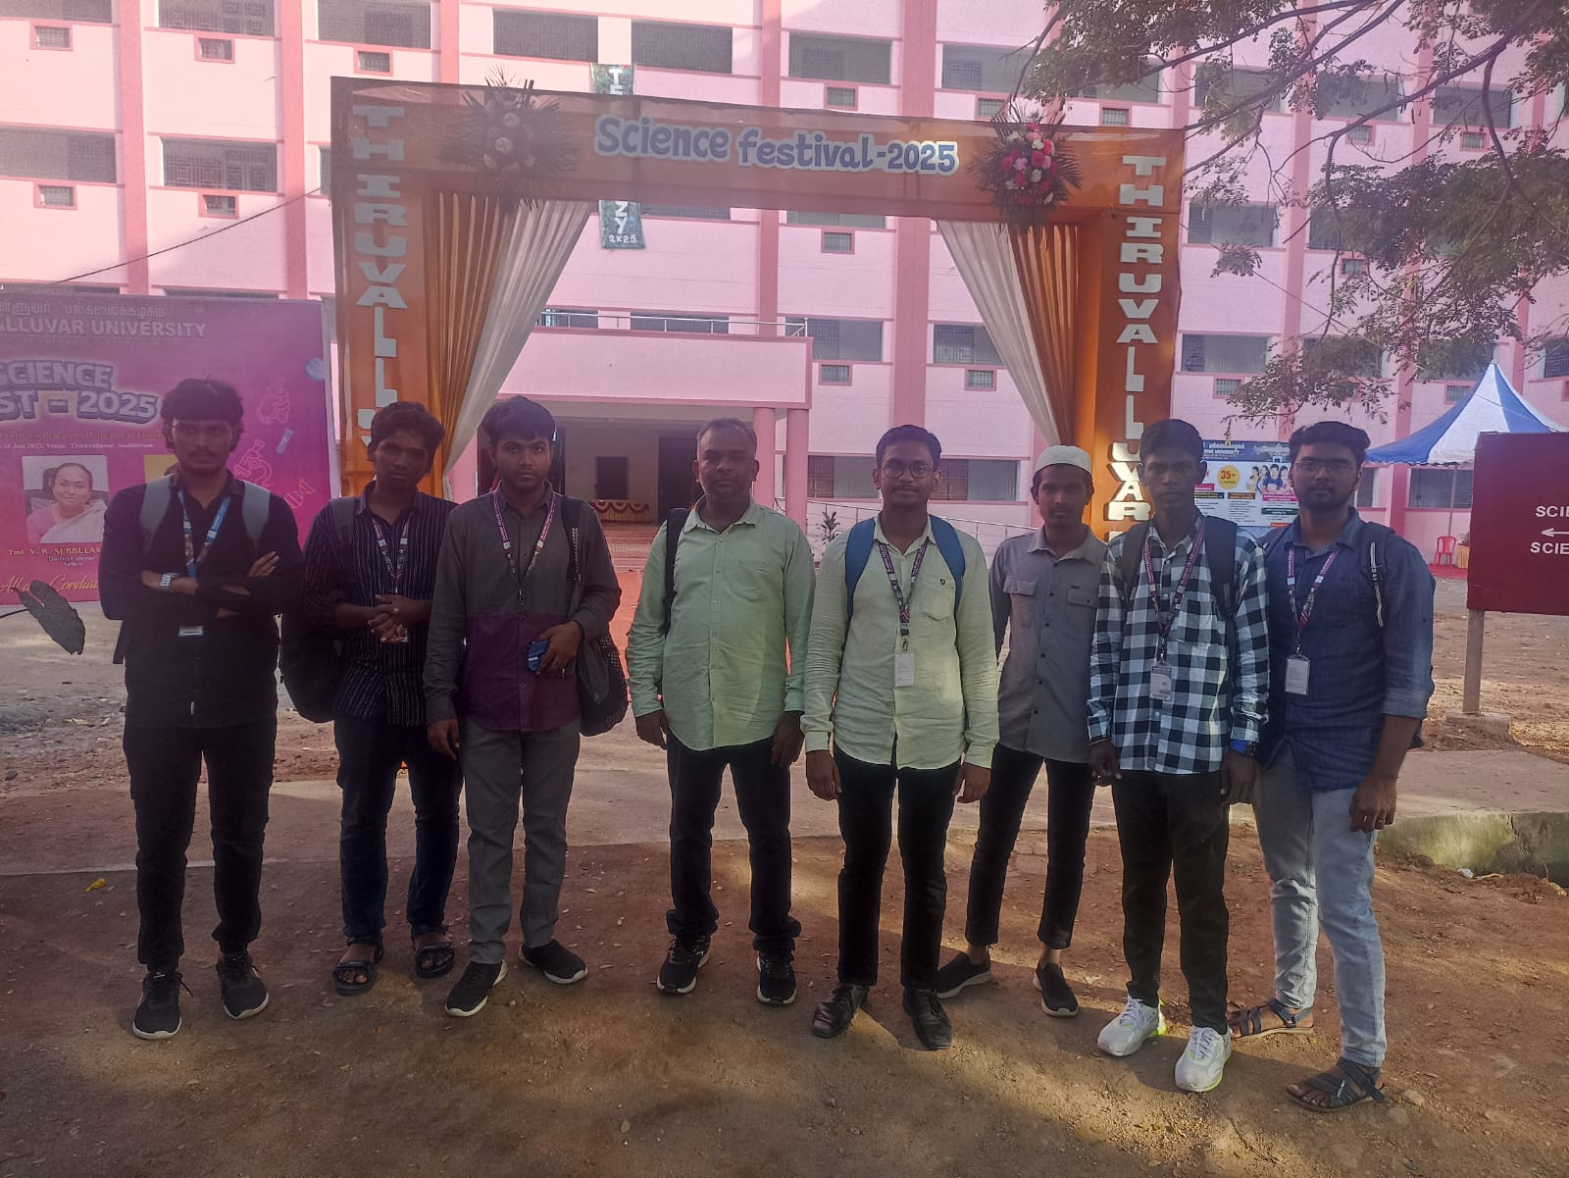
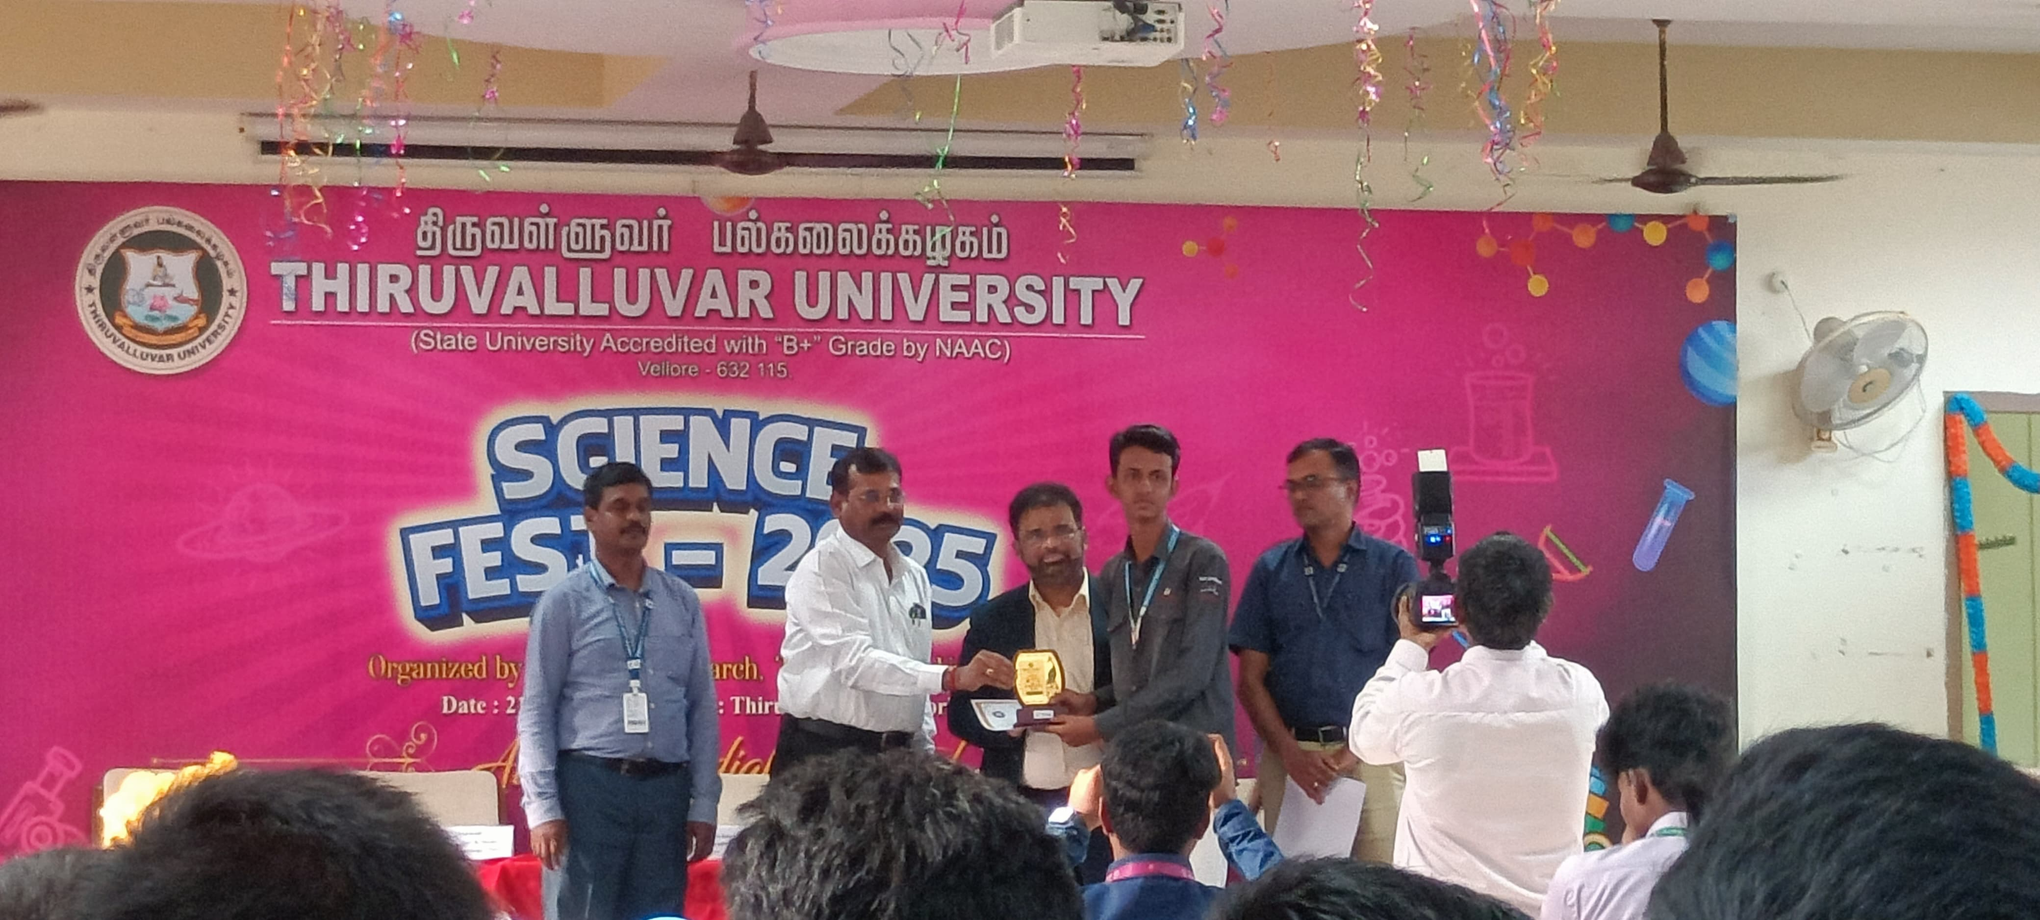
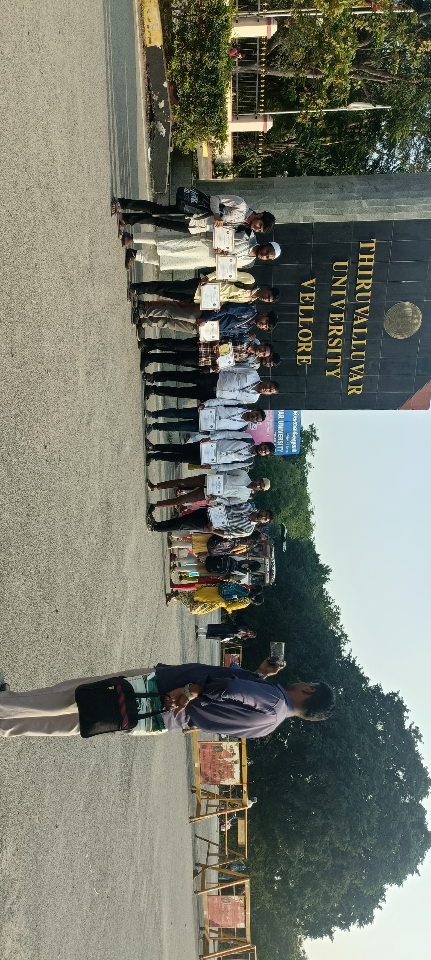

Yours Faithfully
(Dr.S.U.MOHAMMED RIYAZ)

