**DEPARTMENT OF BIOCHEMISTRY**

**ISLAMIAH COLLEGE (AUTONOMOUS)**

**VANIYAMBADI**

**Educational Tour Report – January 2025**

The Department of Biochemistry arranged an educational tour and Industrial for UG and PG Biochemistry students to Munnar and Cochin from 22nd to 25th January 2025. The tour was conducted according to the guidelines laid down by the Regional Joint Director, Vellore. 18 students and 3 staff members accompanied the students.

Students assembled at the college premises at 7.00 P.M on 21.01.2025 and proceeded to Munnar and reached safely by 10 a.m, on 22.01.2025.

**Day 1 on 22-01-2025**

The students and staff members visited **Munnar.** Munnar, South India’s most sought after hill station is not only a favorite tourist spot but also the center of tea estates in Kerala. Munnar, an exotic hill station with enclosed calm of serenity and beauty is the most visited destination in South India.

This hill station is a heavenly beauty situated at an altitude of about 1600 meter from the sea level was once the summer resort of British government in South India. The colonial Bungalows in the hillocks boasts of the glorious past of this place.

**Kerala spice farm:** This government-approved spice garden is renowned for its eco-friendly cultivation methods. Visitors can explore a wide variety of spices and Ayurvedic herbs, gaining insights into organic farming practices.Known for its extensive collection of medicinal herbs, Ayurvedic plants, and common household spices like pepper, nutmeg, cinnamon, cardamom, and cloves. The garden offers informative tours and has an in-house store for purchasing organic spices.

**Pothamedu View Point:**PothameduViewPoint serves as the most perfect tourist spot to unravel the alluring beauty of Munnar’s scenic hills and lush greeneries. A nature lover’s heaven, a hotspot for the adventure freaks, a paradise for shutterbugs, and a treasure trove for the picnic goers, this vantage point offers promising views of the nearby locales.

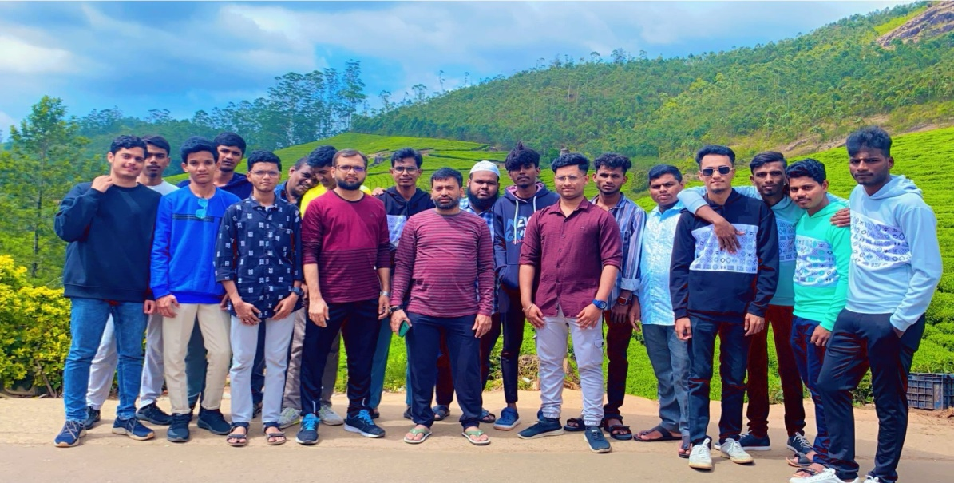

**Carmelgiri Botanical Garden:** Carmelgiri Botanical Garden, located approximately 8 kilometers from Munnar in Kerala's KannanDevan Hills, offers visitors a serene escape into nature's splendor. The garden is renowned for its diverse collection of flora, including a notable variety of cacti, making it one of the largest cactus gardens in southern India.The garden boasts an impressive array of cacti species, attracting both botany enthusiasts and casual visitors.Adjacent to the cactus section, there's a fruit garden showcasing various fruit-bearing plants native to the region.

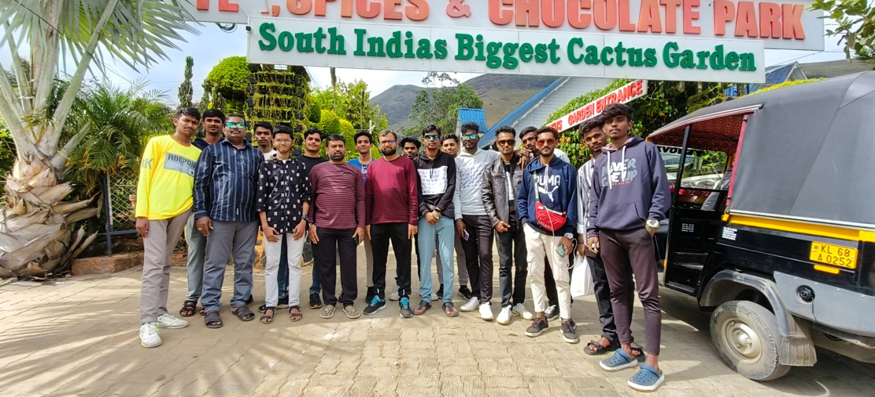

**Echo Point:** Located around 15k from the hill station, it is also known as one of the most mystical places to visit in Munnar.

**Mattupetty Dam:** One of the major tourist attractions in Munnar, this water reservoir in Idukki district is located around 13km from the heart of the hill station. Tucked away amidst towering hills and mountains, it serves as a primary source of hydroelectricity in the region.

**Day 2 on 23-01-2025**

**CMFRI:** Our team visited The Central Marine Fisheries Research Institute which was established by Government of India on February 3rd 1947 under the Ministry of Agriculture and Farmers Welfare and later it joined the ICAR family in 1967.The Institute's multidisciplinary approach to research in marine capture and culture fisheries has won it recognition as a premier institute comparable to any well-established marine laboratory in the world.

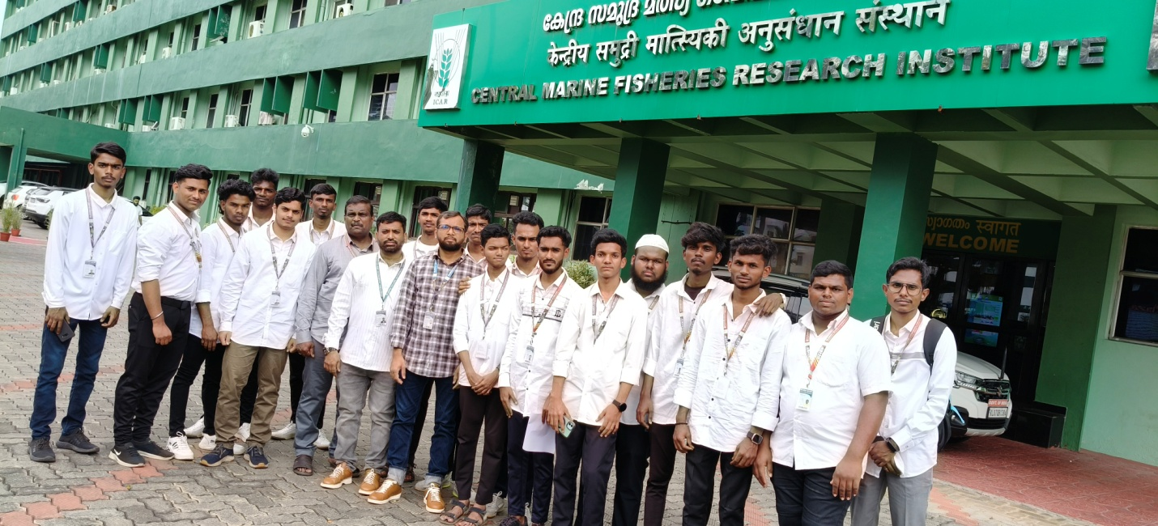

**Marine Research Aquarium and Marine Biodiversity Museum:**The Marine Biodiversity Museum, established at the Headquarters of the Institute offers a glimpse of the biodiversity of the Indian seas displaying specimens collected from estuaries and coastal and deeper waters. The collections, arranged systematically for a better understanding of the resources, attracts students, teachers, scientists and the general public hailing from different States and Union Territories of the country, the students forming more than 80% of the total visitors.

**Lecture Program:** An expert from the institute gave of lecture about the institute, about marine fisheries research undertaken in the institute. Our students enjoyed the lecture program after which large number of questions were raised by our students in regard to fish research and plenty of general questions and the expert answered meticulously to the queries and our students thoroughly enjoyed and benefited by the visit.

**Marine Drive:** Marine Drive is a picturesque promenade in the city of Kochi, Kerala, India.It is built facing the backwaters, and is a popular hangout for the local populace. Ironic to its name, no vehicles are allowed on the walkway. Marine Drive is also an economically thriving part of the city of Kochi.

**Puthuvype Beach:** Puthuvype Beach is a less-visited beach in the Kochi suburbs of Kerala, India. It's a 3-kilometer stretch of golden sand that's ideal for a peaceful getaway. The beach is close to a lighthouse and is known for its beautiful sunsets.

**LuLu International Shopping Mall:**

LuLu International Shopping Mall is a shopping mall located in Kochi, Kerala. It is one of the largest shopping mall in India in terms of total area. With an average daily footfall of more than 80,000, it is one of the most visited places in Kerala. Spanning 17 acres (6.9 ha) with a total built up area of 1.2 million square feet including the multilevel car park the mall has a total retail space of 6.2 lakh square feet.

**Day 3 on 24-01-2025**

**Wonderla:** Our team visit to Wonderla. Wonderla Kochi simply is not just an amusement park, but a world of breath-taking charm. It’s a place to celebrate the smaller moments and share big wonders. Get on one of the exhilarating rides, or simply laze by the pool under the bright sun. But whatever you do, here, everybody gets a little closer and that is why its the best Water and Amusement Park in Kerala.

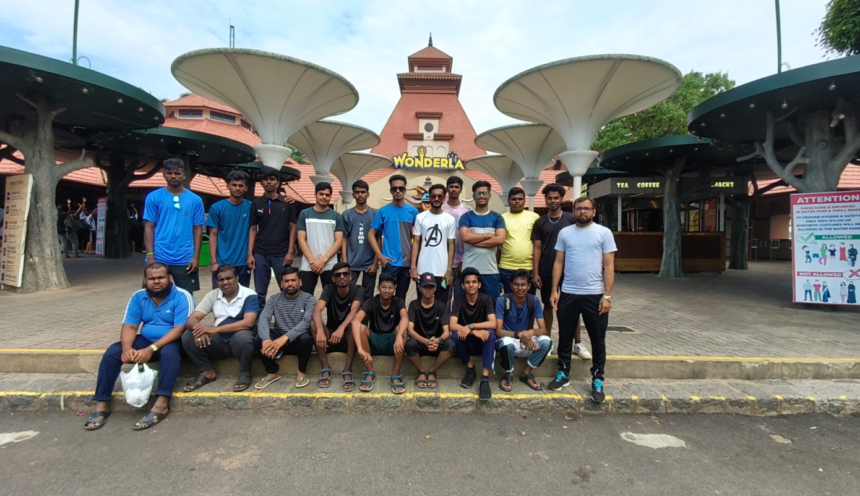

At the end of the tour we reached our college on 25.01.2025. We express sincere thanks to the management and particularly respected secretary and correspondent Janab L. M. Muneer Ahmed Saheb and respected Principal Dr. T. Afsar Basha for their unflinching support and constant encouragement. We thank profusely Regional Joint Director and Collegiate Education, Vellore, for the graceful permission for conducting the educational tour programme successfully.

**Organizers HOD Principal**