

**REPORT ON**



PARENT TEACHER MEET

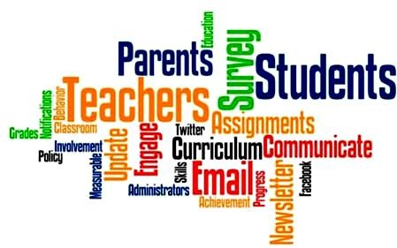

Organized by

**Venue: B.Sc. Biotechnology Lab Date: 04th January 2025, Saturday.**

**Time 10:00 am to 04:30 pm.**

**PARENT TEACHER MEET**

**Introduction**

The Parent-Teacher Meeting (PTM) for the Department of Biotechnology was held on 04th January 2025 at B.Sc. Biotechnology Lab. The purpose of the meeting was to foster stronger communication between faculty members and the parents of Biotechnology students, ensuring the academic and personal well-being of the students. The event provided an opportunity to address any concerns and discuss the overall progress of students in the Department. This meeting also served as a platform to discuss the role of the management in supporting both the students and the faculty for continuous improvement.

The meeting was convened by the Head of the Department of Biotechnology along with the Mentors of I, II and III B.Sc. Biotechnology students.

**Agenda**

The meeting followed a structured agenda to ensure that all important aspects of student progress and departmental updates were covered:

1. **Welcome and Introduction** – Brief introduction of the purpose of the meeting.
2. **Student Engagement and Participation** – Discussion of student involvement in Industrial/Institutional visits, projects, internships, and extra-curricular activities including educational tours.
3. **Department Updates** – Information on upcoming events, opportunities for pursuing M.Sc. Biotechnology and research in the parent institution, and departmental initiatives.
4. **Parental Feedback and Concerns** – An open forum for parents to express their feedback or raise any concerns regarding their ward’s education.
5. **Future Directions** – Discussion of future plans for the Department and how parents can assist in the overall development of the students.

**Key Highlights**

# Academic Performance Overview:

* + The meeting commenced with a brief overview of the academic performance of students in the Department. Mentors shared insights about the performance of students in various subjects and exams. Emphasis was placed on improving academic standards and the integration of research-oriented learning.
  + Mentors also highlighted the achievements of top-performing students and those who participated in conferences, workshops, and competitions.

# Student Engagement and Participation:

* + The Department encourages students to participate in extracurricular activities, internships, and hands-on research projects. This part of the meeting highlighted several student-led initiatives, including biotechnology clubs, workshops, and collaboration with industry partners.
  + Parents were informed about the importance of such engagements for the holistic development of their wards, both academically and personally.

# Department Updates:

* + The Head of the Department presented an update on upcoming research projects, internships, and other professional opportunities for students.
  + The Department also announced a few new collaborations with industry leaders, as well as the launch of new elective courses aimed at equipping students with the necessary skills for emerging fields in biotechnology.

# Parental Feedback and Concerns:

* + Parents were encouraged to share their observations and concerns. Several parents expressed their appreciation for the Department’s approach to student engagement and the quality of teaching.
  + Some parents of I year students raised concerns about the medium of instruction since they were from Tamil Medium. Faculty members assured the parents that efforts would be made to ensure the teaching in both Tamil and English language.

# Future Directions:

* + The Head of the Department discussed plans for the future, including the introduction of more interactive learning methods, and greater collaboration with biotechnology companies.
  + Parents were encouraged to play an active role in supporting the department’s initiatives.

**Action Items and Recommendations**

Based on the feedback received during the meeting, the following action items and recommendations were agreed upon:

1. **Streamlining medium of instruction**: The department will review the teaching method to make learning made easy for I year students.
2. **Enhanced Communication**: The department will establish a clearer communication channel for parents to stay updated on academic and extracurricular activities.
3. **Progress to higher education and Placements**: A more robust counseling service will be implemented to assist students in finding internship opportunities, M.Sc. Programme in our College and post-graduation placements in biotech-related fields.

**GLIMPSES OF PARENT TEACHER MEET**

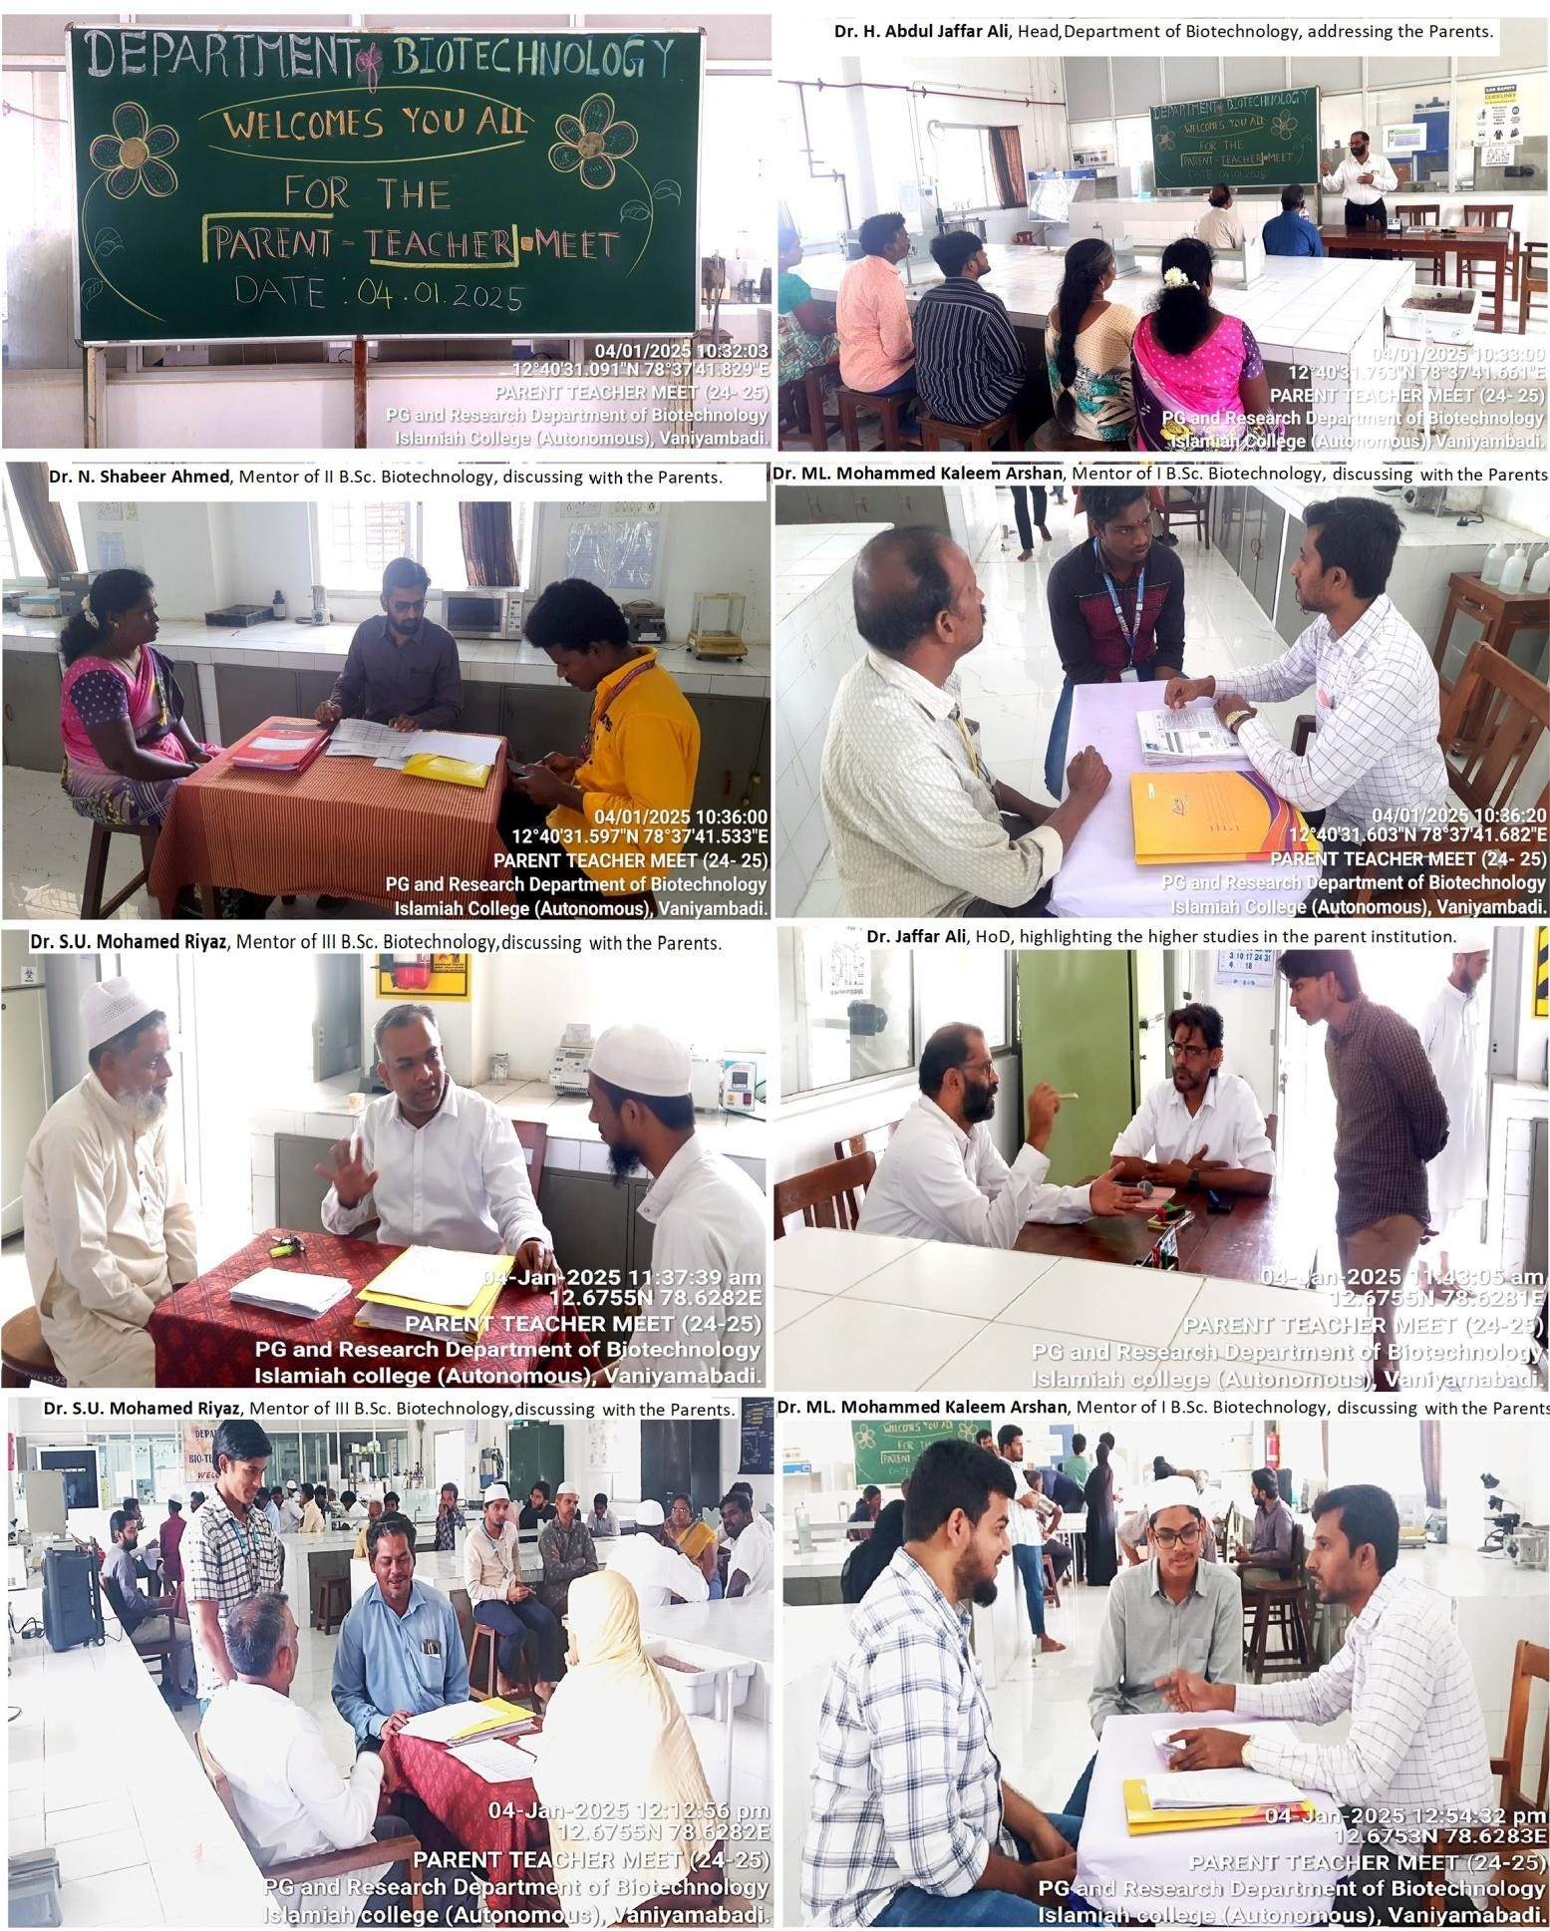

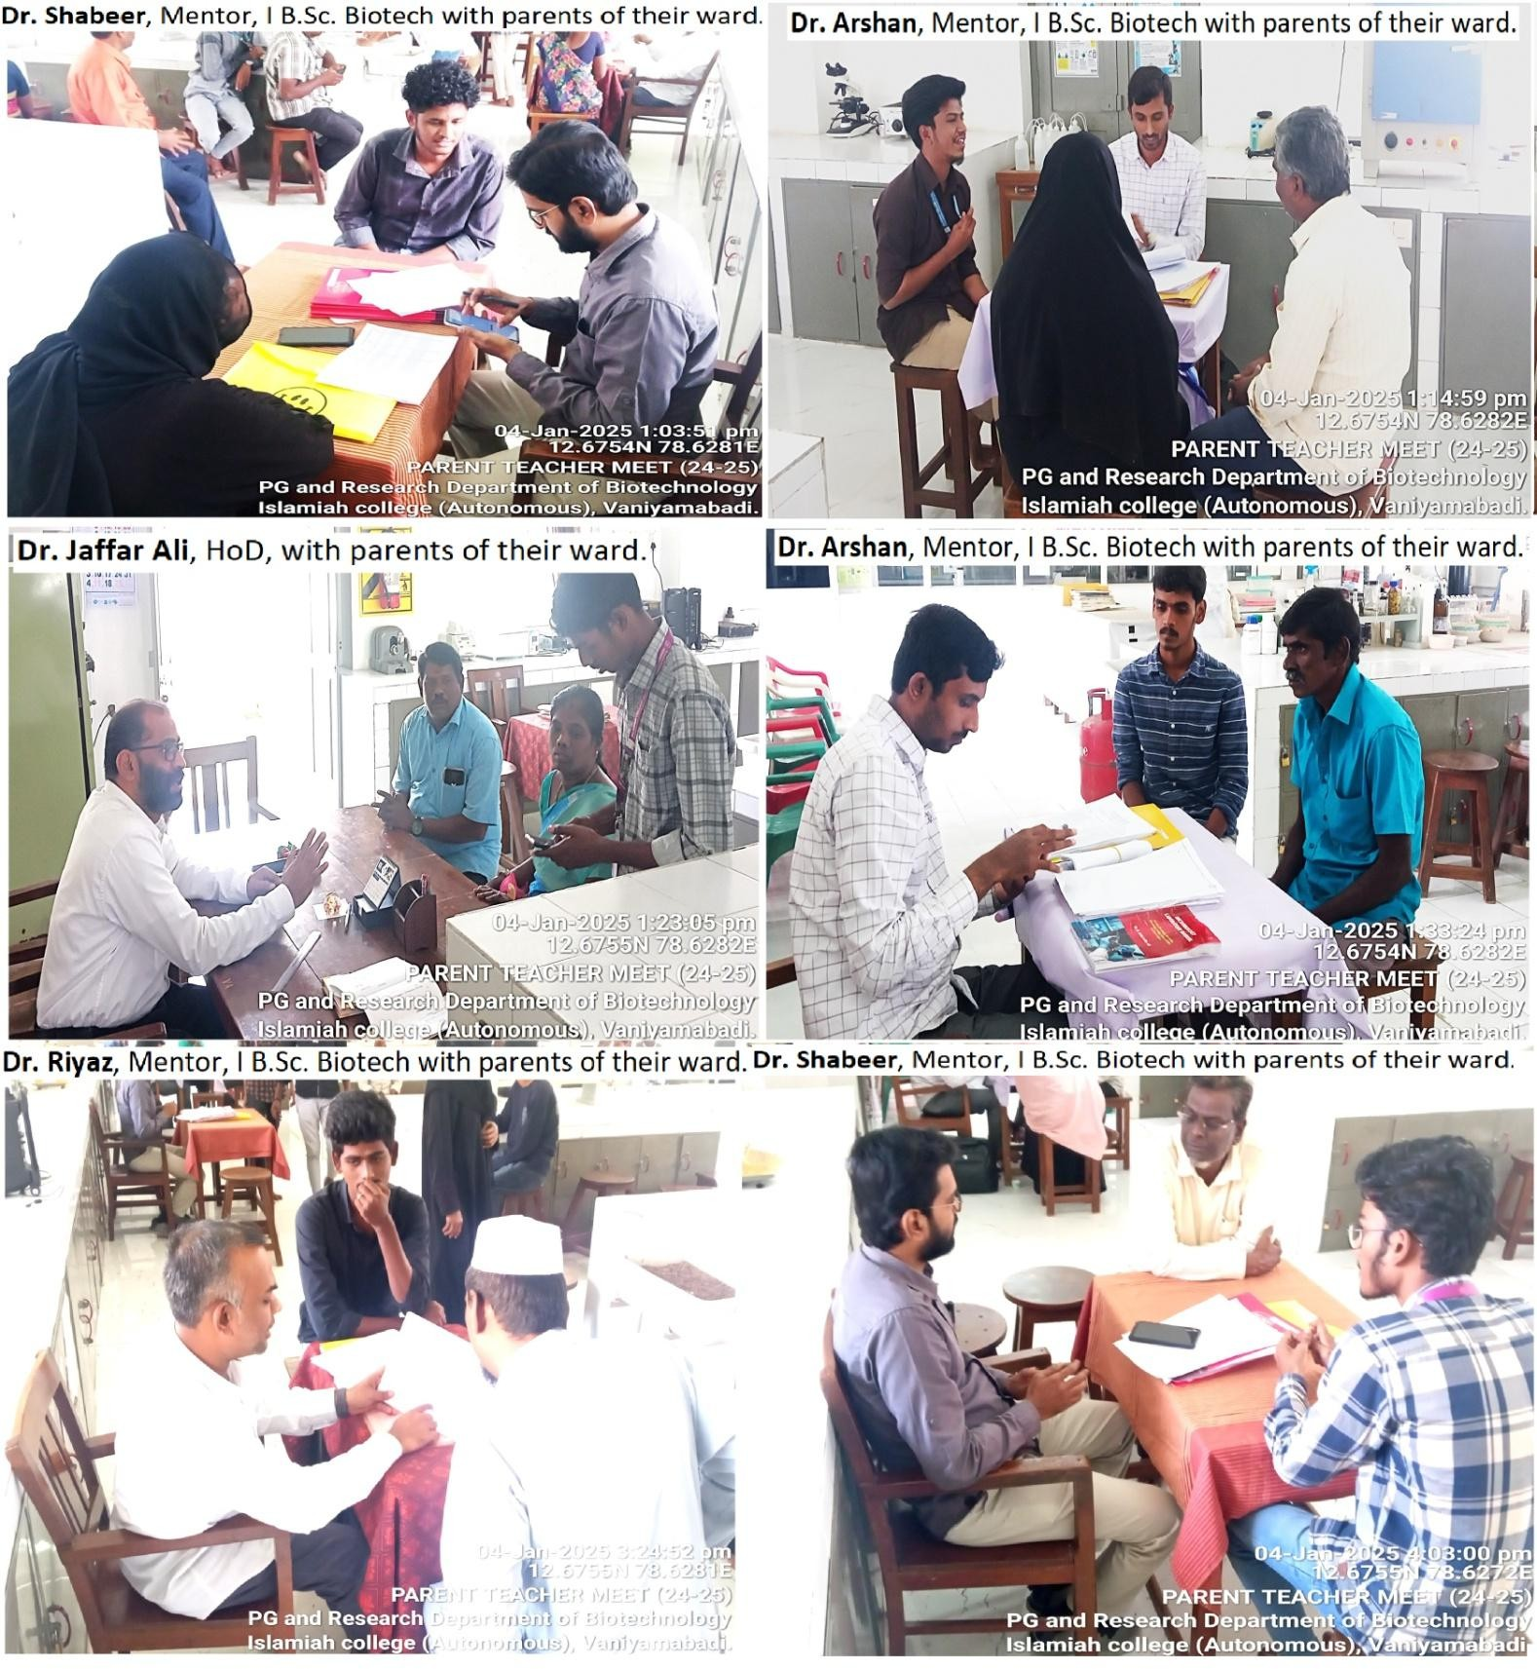

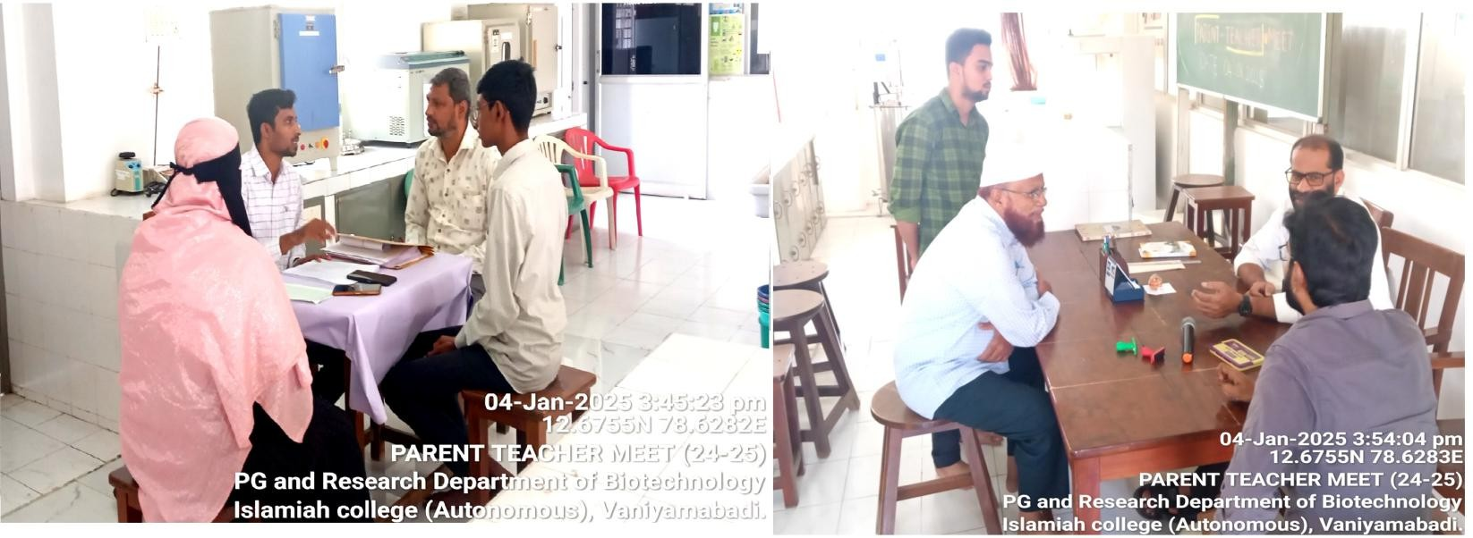

**Conclusion**

The Parent-Teacher Meeting was an informative and productive session that strengthened the relationship between parents and the Department of Biotechnology. The discussions highlighted the Department’s commitment to providing a high-quality education while also ensuring the well-being of students. The feedback and suggestions received will play a crucial role in shaping the future direction of the Department and enhancing the educational experience for biotechnology students. College management also committed to working closely with the department to implement the suggestions and ensure that the needs of students are met.

The Department looks forward to continuing this dialogue with parents to ensure the holistic growth and development of all students.

We would like to extend our heartfelt thanks to the parents/guardians for taking the time to attend this meeting and for their continued partnership in fostering a supportive learning environment for the student.

The Department expresses sincere thanks to the Management, Principal and members of Faculty of Biotechnology for their kind support.

**Head of the Department Principal**