YOUTH RED CROSS
ISLAMIAH COLLEGE (AUTONOMOUS), VANIYAMBADI.

05.01.2025
BLOOD DONATION CAMP ON 23-12-2025
REPORT
In association with the Government Hospital, Vaniyambadi, the Youth Red Cross (YRC) organized a blood donation camp on 23 December 2025 (Tuesday) at 10:00 a.m. in the Allama Iqbal Auditorium. The programme commenced with a welcome address by Dr. A. Gokulakrishnan, YRC Coordinator. The event was presided over by Dr. T. Afsar Basha, Principal, who delivered the presidential address and emphasized the significance of voluntary blood donation as a humanitarian service. Dr. Tanveer Ahmed, M.B.B.S., D.L.O., Blood Bank Officer, Government Hospital, Vaniyambadi, delivered an informative lecture highlighting the importance of blood donation and its role in saving lives. The gathering was further addressed by Rtn. Yelagir V. Selvam, Assistant Governor (Administration), Rotary International District 3231, and Rtn. PHF S. Bhaskar, President, Vaniyambadi Mid Town Rotary Club, who motivated students to actively participate in social welfare initiatives.
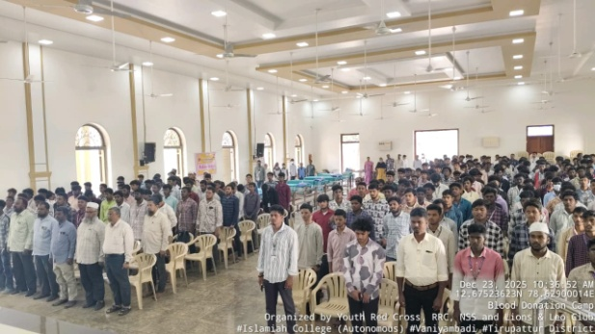
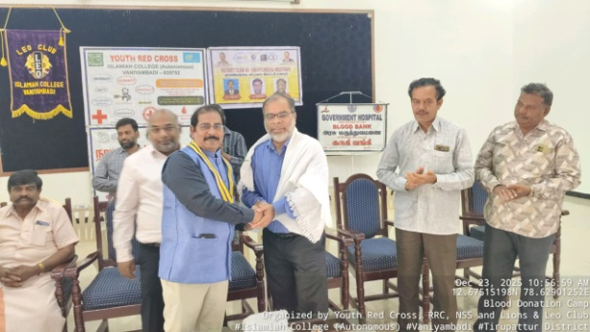
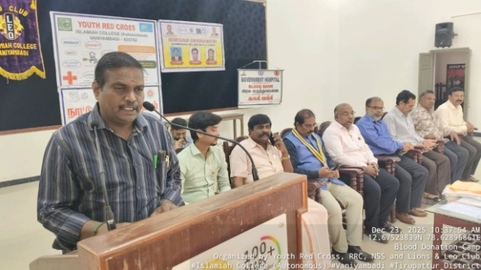
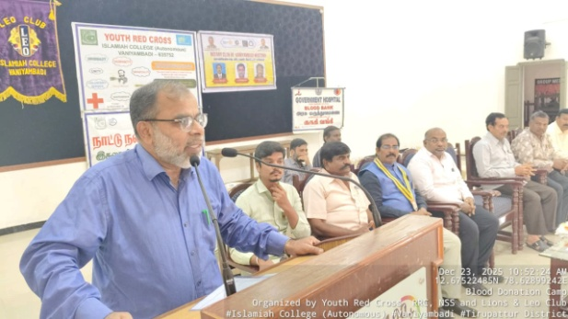
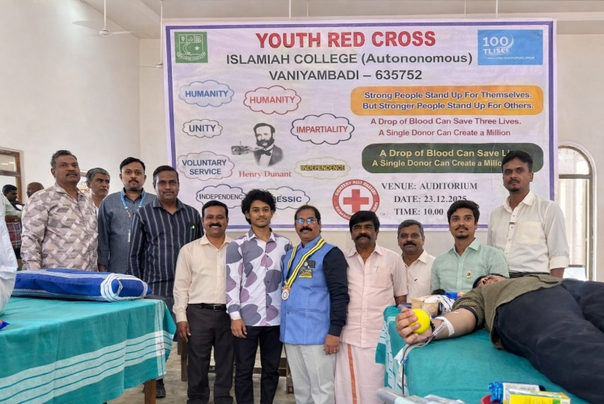

The programme witnessed active participation from the coordinators and members of the YRC, NSS, RRC, and Leo Club. A total of 91 YRC volunteers donated one unit of blood each, which was donated to the Government Hospital, Vaniyambadi. The programme concluded with a vote of thanks proposed by Dr. M. A. Farook, YRC Member. All blood donors were honored with Government-issued certificates and were provided with refreshments as a token of appreciation.

Dr. A. Gokulakrishnan
YRC Coordinator

